# Scholar Saver

Student Budgeting App



System Specification

Toby Smedes

CSC 3150 Systems Design

Andy Cameron

June 2024

Table of Contents

1. Executive Summary 2

2. Introduction 3

2.1. Problem Statement / Project Vision 3

2.2. System Capabilities 3

2.3. Non-Functional Requirements And Design Constraints 4

2.4. System Evolution 4

2.5. Document Outline 6

3. Structural Model 7

3.1. Model Introduction 7

3.2. Class Diagrams 8

3.3. Metadata 9

2.3.1 Bank 10

2.3.2 Cost 12

2.3.3 Expense 14

2.3.4 Expensetype 16

2.3.5 School 17

2.3.6 Transaction 19

2.3.7 User 21

4. Architecture Design 25

4.1. Architecture Overview 25

4.2. Infrastructure Model 26

4.2.1. Deployment Diagram 2 – Architecture Overview 26

4.2.2. Deployment Diagram 2 – Nodes And Artifacts 27

4.3. Hardware And Software Requirements 28

4.3.1. Hardware Components 28

4.3.2. Required Software Components 28

4.4. Security Plan 29

4.4.1. Security Overview 29

4.4.2. Security Plan 29

5. User-Interface 31

5.1. User-Interface Requirements And Constraints 31

5.2. Window/Screen Navigation Diagram 32

5.3. UI Wireframes 33

5.4. Reports: "Formal Output" Design 46

6. Appendices 47

6.1. Glossary 47

6.2. References / Bibliography 48

6.3. Supporting Documentation 48

# **Executive Summary**

This system specification is designed to describe all aspects of the Scholar Saver system. This document is intended for developers working on the project to understand its requirements, constraints, and goals. All this necessary information should be provided in this document. This system specification document can serve as a complete reference for anyone working on the Scholar Saver project.

The developers at BTC should be extremely familiar with mobile development. No specific instruction on mobile development is necessary. The information provided relates to the unique requirements of Scholar Saver. All information that is specific to Scholar Saver is described here.

# **Introduction**

Scholar Saver is a mobile application that is designed to assist students. It helps students learn how to manage their finances better and be more responsible. This is done through several features that help the student see where their money is going and encourage the student to be eager to be fiscally responsible.

Scholar Saver has many features you would expect from a budgeting app, such as transaction history, spending categories, and connections with online banks. What sets Scholar Saver apart is its features, which are designed specifically for students. For example, the user can add upcoming expenses like tuition dues and rent payments with Scholar Saver. Scholar Saver will easily keep track of these and remind the student about them. More information can be found in § 1.0 of the system proposal.

## **Problem Statement / Project Vision**

Resources for the Striving Student (RSS) found a lack of tools for college students to make smart financial decisions and reached out to Big Tech Company (BTC) with a proposed software system. RSS’s goal for this system is to assist in preparing the future generation of laborers to be financially responsible and knowledgeable. With this vision in mind, BTC will develop this proposed system as a mobile application accessible to students. This application will be called Scholar Saver.

Scholar Saver is a mobile application designed to assist students with managing their finances by providing tools through the application. The main functions of this application will be to record and display the user’s recent spending in connection with their banking account and to plan ahead for upcoming expenses and bills. Additionally, that application will provide various resources to encourage financial wisdom and good habits, which are provided by several sources.

## **System Capabilities**

* + 1. **User Account System –** Users must be able to create a secure, individualized account within the mobile application.
    2. **View Spending History (Use Case 1) –** Users must be able to view and track their expenses history over some time.
    3. **Filter Spending History (Use Case 2)** – Within the viewing page of the user’s spending history, they must be able to filter their expenses by date, amount, and category.
    4. **Data Privacy Agreement** – The user will be presented with an agreement on account creation on how their data will be collected and used.
    5. **Connect Online Bank (Use Case 3)** – The user can add and remove connections with their online bank in the application.
    6. **Adjust Expenses (Use Case 5)** – The user must be able to add, remove, and edit expenses within their spending history view.
    7. **Add School Expenses (Use Case 6)** – The user should be able to add upcoming expenses related to their school, such as tuition and room & board.
    8. **View Upcoming Bills and Income (Use Case 8)** – The user must be able to view upcoming expenses through the following year.
    9. **Activate School Membership (Use Case 7)** – Users must be able to enter a code to enroll in the system with their school if they choose to partner.
    10. **View Resources (Use Case 12)** – The user should be able to view resources provided by RSS or, optionally, by their school that assists with financial responsibility.
    11. **Filter Resources (Use Case 13)** – The user should be able to filter the resources provided into categories determined by their medium. (i.e., books, articles, videos)
    12. **Pay for the Premium Version** – The user should be able to pay for the premium version of the application, either as a monthly, quarterly, or annual subscription.
    13. **Scholarship View** – A page where users can view scholarships and other financial aid opportunities.

## **Non-functional Requirements and Design Constraints**

There are several constraints on the design of this product. These and any non-functional requirements are described below. More information on any of these constraints can be found in their respective sections in the system proposal.

* + 1. The minimum viable product (MVP) should be deployed by the start of the upcoming academic year. This is around August to September. See § 1.6.
    2. The MVP should have a goal of 95% uptime with 1,000 simultaneous users. See § 4.4.6.
    3. The product should be easy to use and not pose any learning requirements that are too difficult for the average user see § 4.4.7.
    4. Scholar Saver will use open banking APIs and must adhere to all legal guidelines relating to such APIs.

## **System Evolution**

In the system proposal, many features are outlined that will be absolutely necessary for the initial release of the MVP. However, many other features will be valuable and possibly even necessary to Scholar Saver and will be implemented in future versions. The proposed additions and changes over the two major releases following the initial release are outlined below. Some of these individual features are described in more detail in the system proposal § 6.0.

* + 1. **Version 2 Changes**

For version 2 of Scholar Saver, a sizeable update is planned. The main feature of this second version will be the implementation of the financial literacy resource feature, as mentioned in the system proposal. This will include all use cases related to the literacy resources and all functional requirements. This will be the development team's main focus; thus, we will not have other features outside of this requirement to work on. Version 2 is planned to be released as soon as possible. In addition to this feature, any bugs and security issues found during the initial release will be immediately addressed.

* + - 1. **View Literacy Resources** – Use Case 12 describes this feature. The ability to view financial literacy resources will not be included in the MVP of Scholar Saver. While this feature is extremely valuable to both students and RSS, it has not been deemed necessary and, with the reasonably tight deadline, has been moved to version 2. This will be the main focus for the development team in version 2, along with any major bug fixes that arise.
      2. **Add Literacy Resources** – Use Case 10 describes this feature. In the MVP of Scholar Saver, schools and RSS will not be able to add financial literacy resources to Scholar Saver. This is because there will not be the ability to use and view financial literacy resources in the initial release. This will be part of the main focus for version 2.
      3. **Filter Resources** – Use Case 13 describes this. Users of Scholar Saver will not be able to filter the financial literacy resources in the application. There will be nothing to sort because the literacy resources will not be available in the MVP. For version 2, this will be a key feature that will be developed alongside the literacy resource feature.
    1. **Version 3 and beyond Changes**

For version 3 of Scholar Saver, various features will be implemented to help students with their finances further. These features are not necessary to the success of Scholar Saver, which is why they are not included in the MVP. These features will, however, prove useful to Scholar Saver and are worthwhile to implement in a later version.

* + - 1. **Buying Premium** – Buying the premium version of Scholar Saver will not be part of the MVP. This is because very few users are expected to purchase an individual premium license for the application. Since Scholar Saver’s business model is almost entirely focused on partnerships with schools, most users will not need to buy the premium version independently. Nonetheless, it will be a valuable feature and increase potential revenue. This feature will be planned for the third major release of Scholar Saver.
      2. **Scholarship Resources** – Providing resources related to finding scholarships and scholarships themselves is a feature planned for version 3 of Scholar Saver. This is unnecessary for the MVP and is too much to include in version 2, so it will be planned for version 3. This is an addition to the features planned for version 2. This will also allow users to access scholarships that have been posted by their schools and RSS. The feature will function in a manner similar to financial literacy resources, with the ability to view, add, and filter scholarships.
      3. **Additional Environments** – Another addition later in the lifecycle of Scholar Saver will be to provide the application in environments other than mobile. This could be in the form of a web application, desktop application, or even a lightweight version for wearable devices.

## **Document Outline**

The rest of the specification will be structured as follows:

1. **Structural Model** – This section defines the software model.

**3.1** – Introduces the diagrams.

**3.2** – Class diagram.

**3.3** – Explains each class further and provides its functionality.

1. **Architecture design** – something

**4.1** – Describes the section.

**4.2** – Diagrams modeling the entire system.

**4.3** – Necessary hardware and software components.

**4.4** – Explains the security plan for the Scholar Saver system.

1. **User-Interface** – Explains the user interface.

**5.1** – Describes the section.

**5.2** – Diagram of the screen navigation.

**5.3** – Low-resolution wireframes of each screen.

**5.4** – Reports created.

1. **Appendices** – Additional materials.

**6.1** – Glossary of terms.

**6.2** – Reference materials.

**6.3** – Supporting documentation.

# **Structural Model**

## **Model Introduction**

A class diagram of the necessary components for the MVP is pictured below. All essential information for the implementation of these features is included. More detail about each class is explained in § 3.3.

## **Class Diagrams**

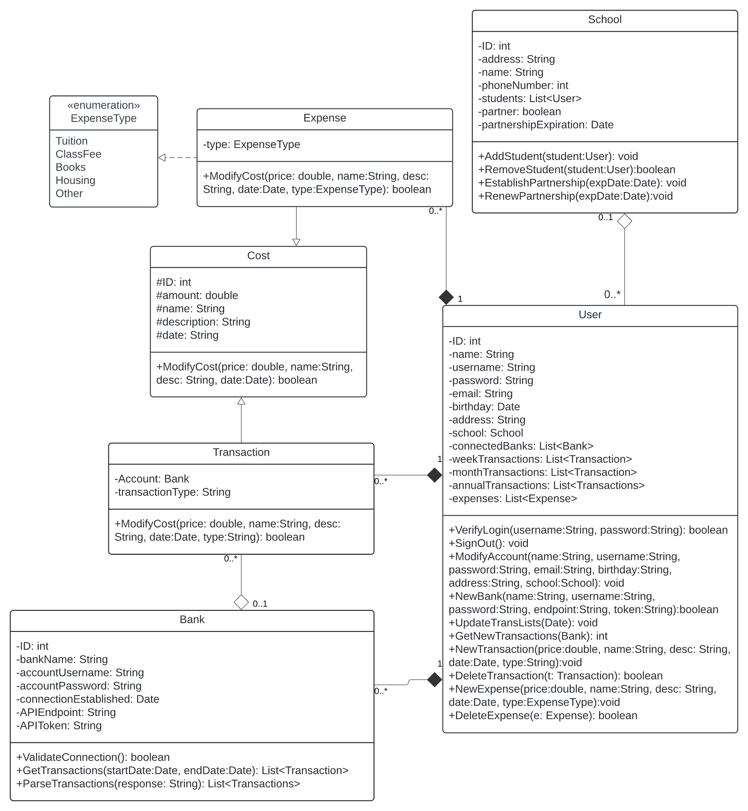

[Link to LucidChart Diagram](https://lucid.app/lucidchart/258e7b1b-def1-48fd-a9ab-3bd02e8f303e/edit?viewport_loc=-401%2C-954%2C2927%2C2108%2CHWEp-vi-RSFO&invitationId=inv_5dd5f072-6427-41fa-ab60-bfef47360b11)

## **Metadata**

This section outlines each class from the above class diagram in more detail. Below, you will find further details about each class, what each member does, and the basic implementation of the features. The classes are listed in alphabetical order as follows:

**2.3.1 Bank** 8

**2.3.2 Cost** 10

**2.3.3 Expense** 12

**2.3.4 ExpenseType** 14

**2.3.5 School** 15

**2.3.6 Transaction** 17

**2.3.7 User** 19

**2.3.1 Bank**

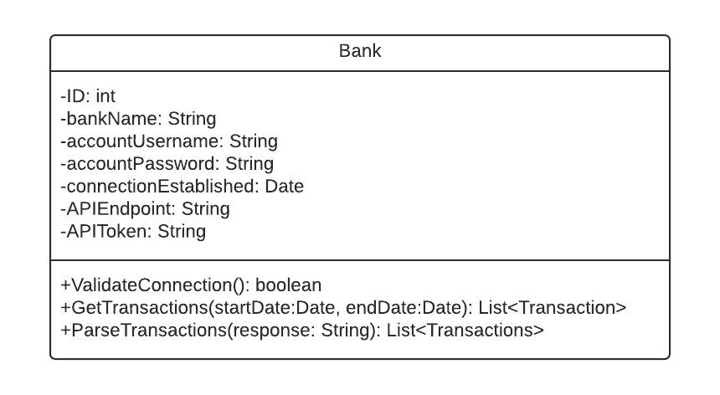

Description: Represents a user’s online banking account.

Visibility: Public

Is Abstract: No

Additional Information:

**Attributes**

|  |  |  |  |  |
| --- | --- | --- | --- | --- |
| Name | Description | Read Only? | Multiplicity | Derived? |
| ID | Unique identifier | Yes | 1 | No |
| bankName | Name of bank | Yes | 1 | No |
| accountUsername | User’s username for bank | No | 1 | No |
| accountPassword | User’s password for bank | No | 1 | No |
| connectionEstablished | Date the connection was last validated | No | 1 | No |
| APIEndpoint | URL to access API | Yes | 1 | No |
| APIToken | User’s unique API token | Yes | 1 | No |

**Operations**

|  |  |  |  |
| --- | --- | --- | --- |
| Name | Description | Query? | Polymorphic? |
| ValidateConnection | Attempts to login to user’s account and acces the API to check the endpoint and token | Yes | No |
| GetTransactions | Performs an API call with the user’s banking information. | No | No |
| ParseTransactions | Parses the return from the API call and adds the transactions to the database. | No | No |

**Processing Outlines**

**ValidateConnection()**

TRY

Sign in to online bank

Validate Token against endpoint

Perform a blank GET request to endpoint

connectionEstablished = today

Return true

CATCH

Error

Return False

**GetTransaction(startDate, endDate)**

IF !ValidateConnection

Error

ELSE

GET request from endpoint

ParseTransaction(response)

**ParseTransactions(response)**

WHILE response has a transaction

Add transaction to database

**2.3.2 Cost**

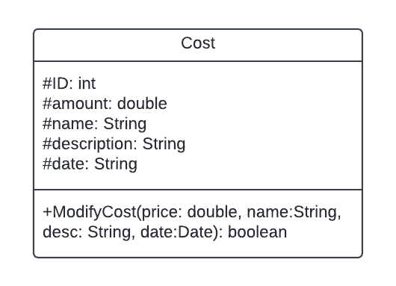

Description: Represents a cost for the user.

Visibility: Public

Is Abstract: Yes

Additional Information:

**Attributes**

|  |  |  |  |  |
| --- | --- | --- | --- | --- |
| Name | Description | Read Only? | Multiplicity | Derived? |
| ID | Unique identifier | Yes | 1 | No |
| amount | Cost of the expense | No | 1 | No |
| name | Name of the expense | No | 1 | No |
| description | Description of the expense | No | 1 | No |
| date | Date the expense is due | No | 1 | No |

**Operations**

|  |  |  |  |
| --- | --- | --- | --- |
| Name | Description | Query? | Polymorphic? |
| ModifyCost | Modifies the information about the expense | No | Yes |

**Processing Outlines**

**ModifyCost(price, name, desc, date)**

Amount = price

Name = name

Description = desc

Date = date

**2.3.3 Expense**

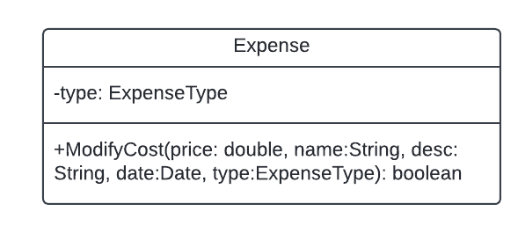

Description: Represents a user’s upcoming expense or bill.

Visibility: Public

Is Abstract: No

Additional Information:

**Attributes**

|  |  |  |  |  |
| --- | --- | --- | --- | --- |
| Name | Description | Read Only? | Multiplicity | Derived? |
| ID | Unique identifier | Yes | 1 | Yes |
| amount | Cost of the expense | No | 1 | Yes |
| name | Name of the expense | No | 1 | Yes |
| description | Description of the expense | No | 1 | Yes |
| date | Date the expense is due | No | 1 | Yes |
| type | The type of expense | No | 1 | No |

**Operations**

|  |  |  |  |
| --- | --- | --- | --- |
| Name | Description | Query? | Polymorphic? |
| ModifyCost | Modifies the information about the expense | No | Yes |

**Processing Outlines**

**ModifyCost(price, name, desc, date, type)**

Amount = price

Name = name

Description = desc

Date = date

Type = type

**2.3.4 ExpenseType**

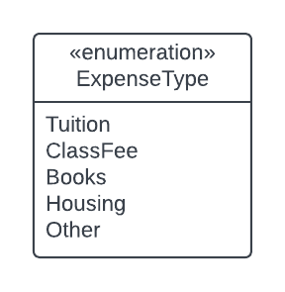

Description: Enumeration of the types of expenses

Visibility: Private

Is Abstract: No

Additional Information:

**Enumerators**

|  |  |
| --- | --- |
| Name | Description |
| Tuition | Costs related to tuition |
| ClassFee | Fees for classes |
| Books | Textbook costs |
| Housing | Rent or on-campus costs |
| Other | Anything else |

**2.3.5 School**

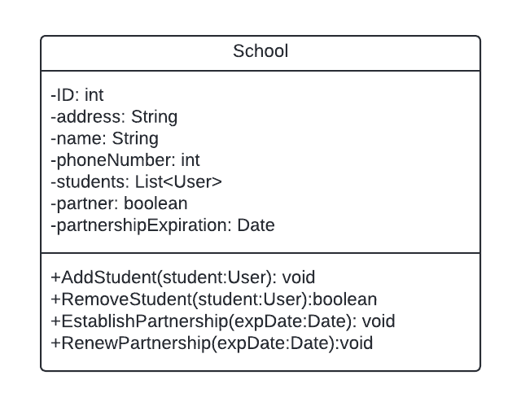

Description: Represents an academic institution.

Visibility: Public

Is Abstract: No

Additional Information:

**Attributes**

|  |  |  |  |  |
| --- | --- | --- | --- | --- |
| Name | Description | Read Only? | Multiplicity | Derived? |
| ID | Unique identifier | Yes | 1 | No |
| address | School’s address | No | 1 | No |
| name | Name of the school | No | 1 | No |
| phoneNumber | School’s phone number | No | 0..* | No |
| students | List of user’s enrolled | No | 0..* | No |
| partner | Determines if the school has partnered with Scholar Saver | No | 1 | No |
| partnershipExpiration | The date the partnership contract ends | No | 1 | No |

**Operations**

|  |  |  |  |
| --- | --- | --- | --- |
| Name | Description | Query? | Polymorphic? |
| AddStudent | Adds student to school | No | No |
| RemoveStudent | Removes student from school | No | No |
| EstablishPartnership | Establishes a partnership with the school | No | No |
| RenewPartnership | Renews partnership, increasing valid time | No | No |

**Processing Outlines**

**AddStudent(user)**

StudentList.Add(user)

**RemoveStudent(user)**

IF StudentList.Add(user)

Return true

Return false

**EstablishPartnership(expDate)**

partnership = true

partnershipExpiration = expdate

**RenewPartnership(expDate)**

partnership = true

partnershipExpiration = expdate

**2.3.6 Transaction**

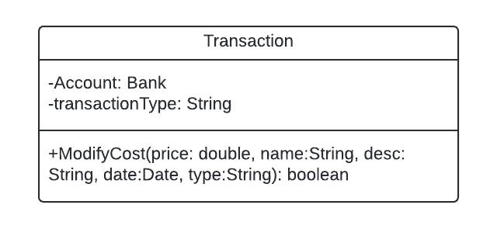

Description: Represents a past transaction by the user.

Visibility: Public

Is Abstract: No

Additional Information:

**Attributes**

|  |  |  |  |  |
| --- | --- | --- | --- | --- |
| Name | Description | Read Only? | Multiplicity | Derived? |
| ID | Unique identifier | Yes | 1 | Yes |
| amount | Price of the transaction | No | 1 | Yes |
| name | Name of the transaction | No | 1 | Yes |
| description | Description of the transaction | No | 1 | Yes |
| date | Date the transaction occured | No | 1 | Yes |
| transactionType | The type of transaction | No | 1 | No |
| account | The bank that the transaction went through | Yes | 1 | No |

**Operations**

|  |  |  |  |
| --- | --- | --- | --- |
| Name | Description | Query? | Polymorphic? |
| ModifyCost | Modifies the data of the transaction | No | Yes |

**Processing Outlines**

**ModifyCost(price, name, desc, date, type)**

Amount = price

Name = name

Description = desc

Date = date

expenseType = type

**2.3.7 User**

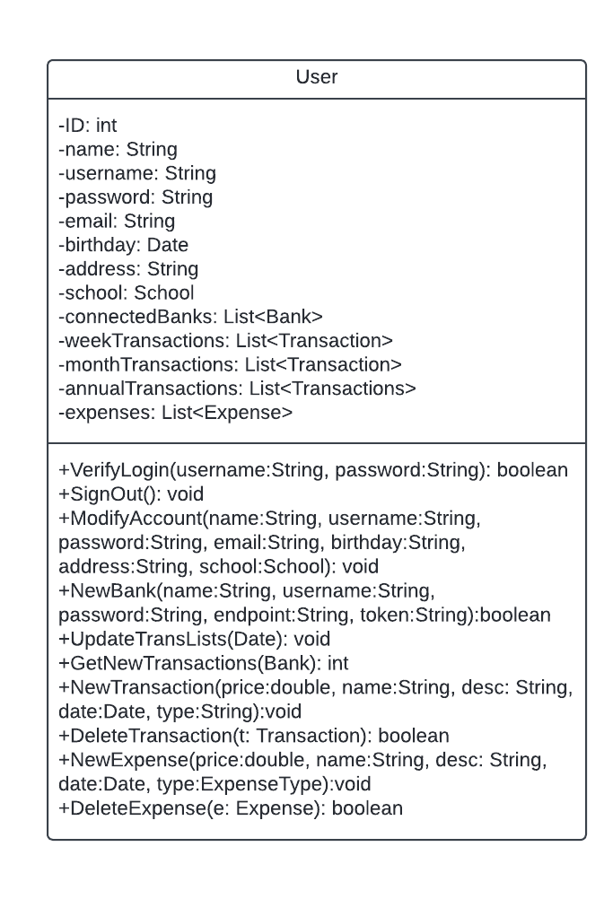

Description: Represents a user (student).

Visibility: Public

Is Abstract: No

Additional Information:

**Attributes**

|  |  |  |  |  |
| --- | --- | --- | --- | --- |
| Name | Description | Read Only? | Multiplicity | Derived? |
| ID | Unique identifier | Yes | 1 | No |
| name | Student’s name | No | 1 | No |
| username | Student’s username | No | 1 | No |
| password | Student’s password | No | 1 | No |
| email | Student’s email | No | 1 | No |
| birthday | Student’s email | No | 1 | No |
| address | Student’s address | No | 1 | No |
| school | Student’s enrolled school | No | 1 | No |
| connectedBanks | Online banks the user has connected | No | 0..* | No |
| weekTransactions | The last week of transactions | No | 0..* | No |
| monthTransactions | The last month of transactions | No | 0..* | No |
| annualTransactions | The last year of transactions | No | 0..* | No |
| expenses | All upcoming expenses | No | 0..* | No |

**Operations**

|  |  |  |  |
| --- | --- | --- | --- |
| Name | Description | Query? | Polymorphic? |
| VerifyLogin | Verifies authenticity of login | Yes | No |
| SignOut | Signs user out | Yes | No |
| ModifyAccount | Updates account details | No | No |
| NewBank | Adds new connected bank | No | No |
| UpdateTransList | Updates transaction lists based on the date | No | No |
| GetNewTransactions | Updates latest transactions from banks | No | No |
| NewTransaction | Adds new transaction manually | No | No |
| DeleteTransaction | Deletes a transaction | No | No |
| NewExpense | Adds new expense | No | No |
| DeleteExpense | Deletes an expense | No | No |

**Processing Outlines**

**VerifyLogin(username, password)**

IF username == username and password == password

Return true

ELSE

Return false

**ModifyAccount(name, username, password, email, birthday, address, school)**

Name = name

Username = username

Password = password

Email = email

Birthday = birthday

Address =address

School = school

**NewBank(name, username, password, endpoint, token)**

Bank(name, username, password, endpoint, token)

Add Bank to connectedBanks

**UpdateTransList(date)**

GetNewTransactions

If any transactions are not in database, remove them

FOR trans in annualTransactions

IF trans is older than 1 year

Remove trans from annualTransactions

FOR trans in monthTransactions

IF trans is older than 1 month

Remove trans from monthTransactions

FOR trans in weekTransactions

IF trans is older than 1 week

Remove trans from weekTransactions

**GetNewTransactions(Bank)**

Bank.GetTransactions()

Get Transactions from database into each Transaction List

**NewTransaction(price, name, desc, date, type)**

New Transaction(price, name, desc, date, type)

Add Transactions to database

UpdateTransList(today)

**DeleteTransaction(t)**

Remove t from database

UpdateTransList(today)

**NewExpense(price, name, desc, date, type)**

New Expense(price, name, desc, date, type)

Add expense to database

Get expenses from databse and add to expense List

**DeleteExpense(e)**

Remove e from database

Update expense List from database

# **Architecture Design**

## **Architecture Overview**

This section describes the system architecture of Scholar Saver. In this section, you will find information about the interaction between different layers of the Scholar Saver system. Additionally, all required software and hardware components are listed here. Scholar Saver also has a robust security system for protecting user data. The security plan can be found in this section.

Scholar Saver is a 3-tier client-server system. Scholar Saver’s processing is distributed among multiple servers and devices. The three tiers in this architecture are client, application logic, and database. Scholar Saver will use a relational SQL database for its database tier, using cloud-based servers provided by Microsoft Azure.

## **Infrastructure Model**

* + 1. **Deployment Diagram 2 – Architecture Overview**

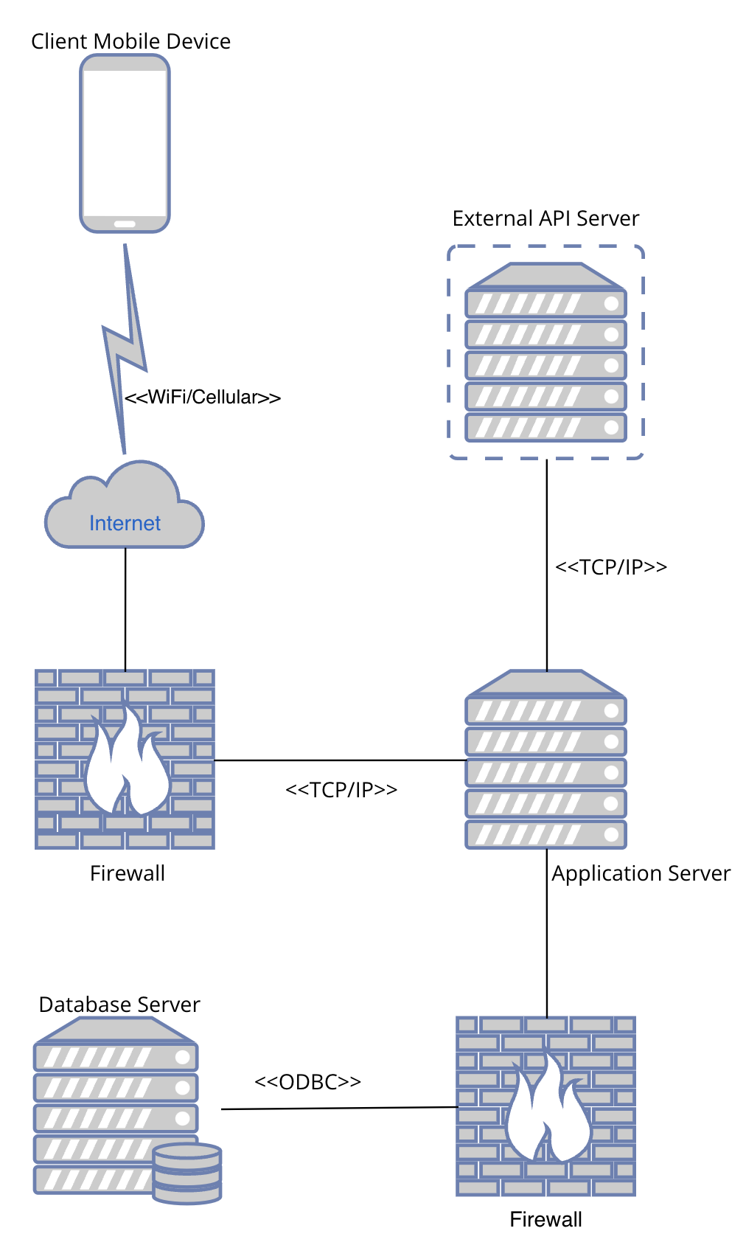

Deployment Diagram 1

* + 1. **Deployment Diagram 2 – Nodes and Artifacts**

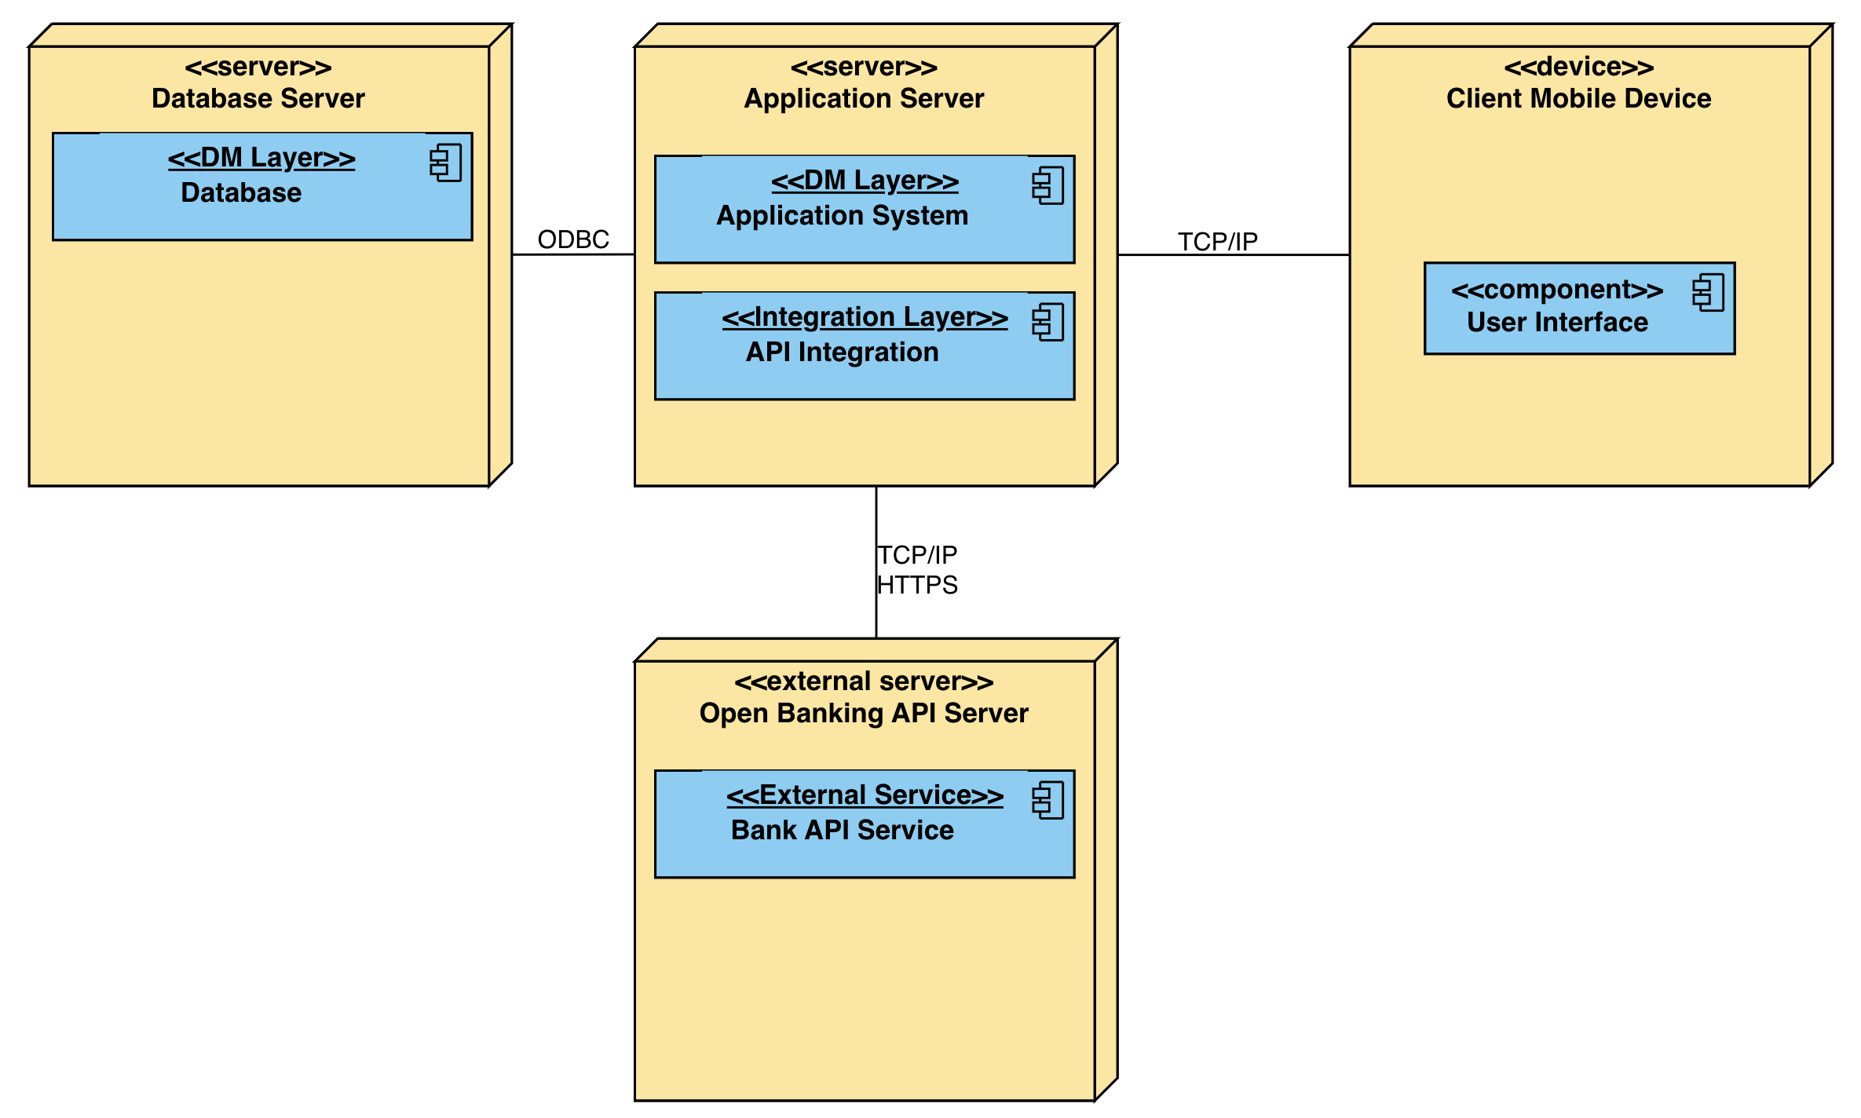

Deployment Diagram 2

## **Hardware and Software Requirements**

This Section describes the necessary hardware and software components to build this system. Minimal new hardware and software will be needed due to BTC’s experience with mobile development. Cloud computing is required, however.

* + 1. **Hardware Components**

Some hardware is necessary for Scholar Saver to function effectively. Users need mobile devices to access the application. Additionally, users need internet access, either through cellular connectivity or a router that provides a WiFi connection.

The system does not require any new hardware to be acquired. Instead, the application and database servers will be hosted on Microsoft Azure’s cloud-based web servers.

1. Azure’s D4 v3 instance will be utilized for the application server. This offers the application server with Azure’s latest generation of CPUs.
2. For the database server, we will purchase Microsoft Azure’s SQL database service. This is a cloud-based server that runs SQL databases. The allocated server size is elastic, and Microsoft will charge us proportionately.
   * 1. **Required Software Components**

Some new software will be necessary for Scholar Saver to function.

* Microsoft Azure will be used for cloud-based server management. Several pieces of software provided by Azure will be used, like Azure Key Vault and Microsoft Defender for the Cloud.
* In order to properly use Scholar Saver, we will need access to the APIs and authentication resources of online banking systems.
* No new IDEs or development tools are necessary, as the development team is very experienced with mobile development.
* Git and GitHub (version 2.45.2) will be used by the team to track version history and keep logs of the project as they work on it.

## **Security Plan**

* + 1. **Security Overview**

Security is essential to Scholar Saver due to the nature of the system. Because Scholar Saver deals with sensitive banking information, a strong security system is absolutely crucial.

Personal data like usernames, passwords, and authentication tokens for open banking APIs will be encrypted with Azure Key Vault. Azure Key Vault is a service provided by Microsoft Azure that encrypts sensitive information like passwords. Transactions that have been recorded from the banking APIs do not need to be backed up because they can be retrieved from the banking connection at any time.

* + 1. **Security Plan**

Below is a table detailing the threats to the Scholar Saver system. The management of these threats is explained below the table.

|  |  |  |  |  |  |  |  |  |
| --- | --- | --- | --- | --- | --- | --- | --- | --- |
| Threats  Components | Natural Disaster | | | | Unauthorized Access | | | |
| Fire | Flood | Power Loss | Circuit Failure | Virus | Eavesdrop | Intruder | Data Breach |
| Client Mobile Device | 4 | 4 | 4 | 4 | 3 | 1,2,7 | 1,3 |  |
| Internet |  |  |  |  |  | 2,7 |  |  |
| Azure Application Server |  |  |  |  | 5,8 | 2 | 5,8 | 6,9 |
| API Server |  |  |  |  |  | 2,7 | 9 | 9 |
| Azure SQL Server |  |  |  |  | 5,8, 10 | 2 | 5,8 | 6,9, 10 |

**Controls**

1. Require login on each startup of the plication
2. Secure Sockets Layer (SSL) and Transport Layer Security (TLS)
3. Strong password requirement
4. All of the user’s transaction data is stored on a cloud database server
5. Antivirus Software – Microsoft Defender for the Cloud
6. Azure Key Vault software encrypts passwords
7. HyperText Transfer Protocol Secure (HTTPS)
8. Firewall
9. Data encryption
10. All transactions can be backed up from the banking API

# **User-Interface**

## **User-Interface Requirements and Constraints**

In this section, you will find wireframes and diagrams representing the user-interface (UI) of Scholar Saver. The diagrams in this section are low-resolution, and consist only of the most necessary elements to function. You will see mostly just buttons, text inputs, and labels in these diagrams. All artistic elements have been left out for simplicity.

## **Window/Screen Navigation Diagram**

The diagram below comprises each individual page or input element necessary for the mobile application. The type of screen that is shown is enclosed in “<<” and “>>” at the top of each box. Input elements and buttons are shown inside each box, with the exception of the “ComboBox” elements, which contain their values. Buttons are highlighted for distinction. The connection between pages is shown by arrows pointing toward the flow of events. For example, if a user is on the Login page and wants to Sign Up, they are redirected to the Sign Up page when they click the “Sign Up” button.

[Link to Window Navigation Diagram](https://lucid.app/lucidchart/27c8e1df-0f84-4897-ace1-c6c3b09a8878/edit?viewport_loc=-1640%2C-895%2C4207%2C3029%2CHWEp-vi-RSFO&invitationId=inv_e5969992-4b2c-4f53-ac90-4fa2abfe681c)

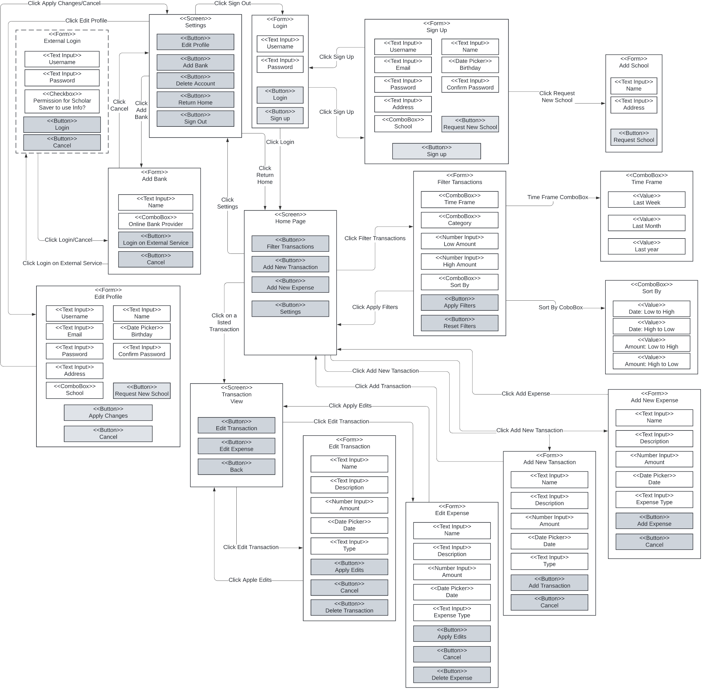

## **UI Wireframes**

This section contains a more detailed visualization of each page in the above diagram. Each diagram here, a wireframe, is a different page that can be accessed within the app. Because the association between these pages is shown in the previous diagram, they will not be displayed here.

Each wireframe is designed to display the layout of elements and the necessary features of each page. For reference, the title of each page is at the top of the screen.

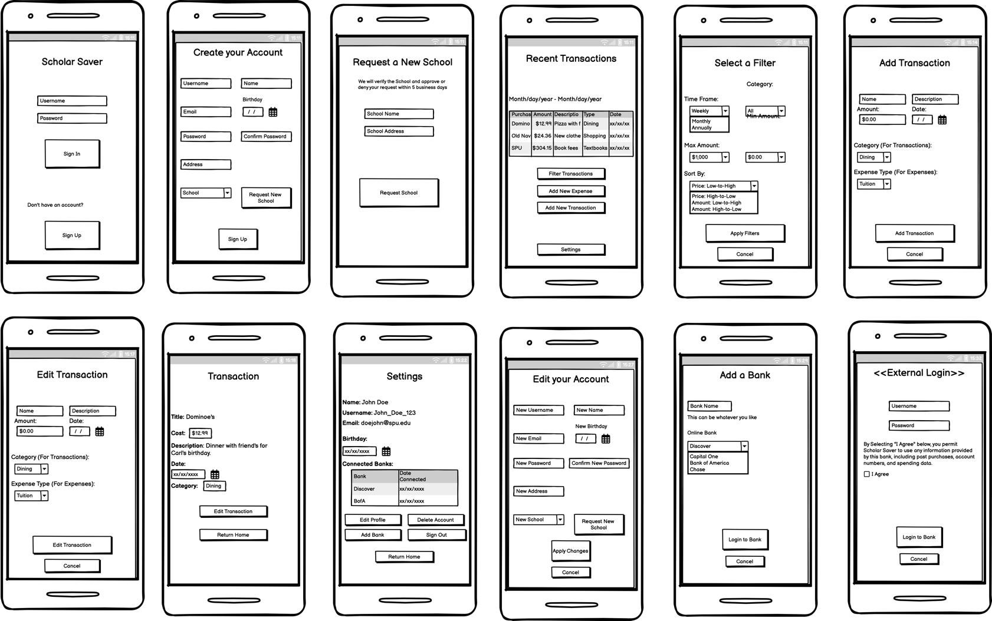

**5.3.1 Login**

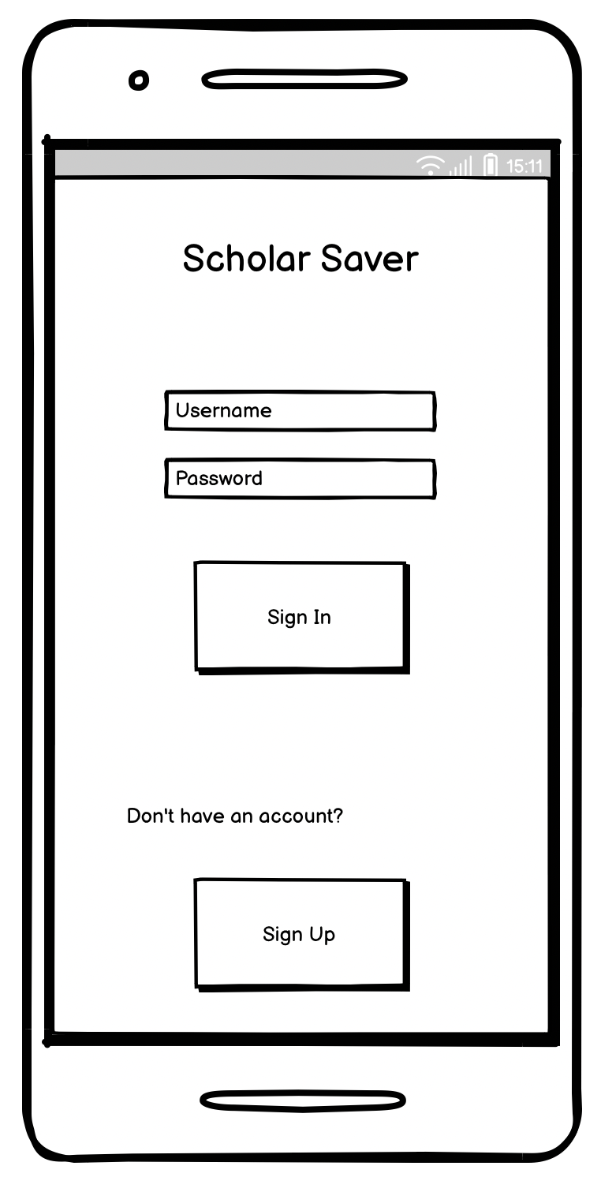

This is the application's landing page. Whenever you open Scholar Saver on a mobile device, this is the page that the user sees first. We like to keep the first page the user sees to be quite simple. It contains a simple login system and an option to create a new account that will redirect the user to another page.

This page will also mean a lot for the branding of Scholar Saver as a mobile application. Designers may want to pay attention to this and ensure the Scholar Saver brand is displayed well.

**5.3.2 Sign Up**

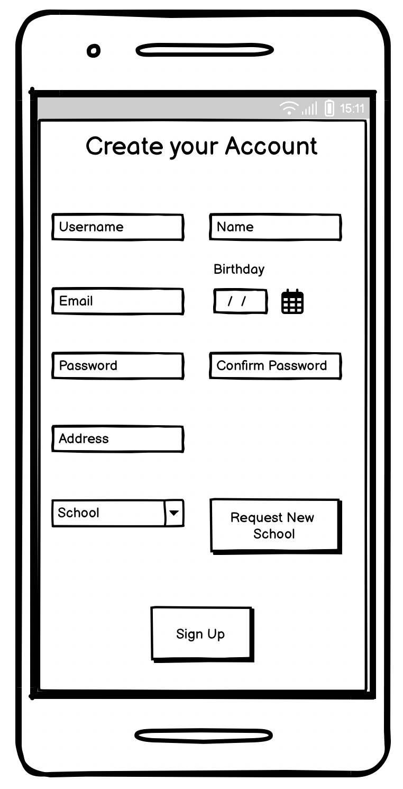

This is the account creation page. From the login page, if the user decides to sign up for a new account, they will be redirected to this page. All the input elements here will be assigned to the user, and a new account will be created.

All of the input elements on this page are required except for the school option. We welcome users to use Scholar Saver, even if they are not students.

**5.3.3 Request New School**

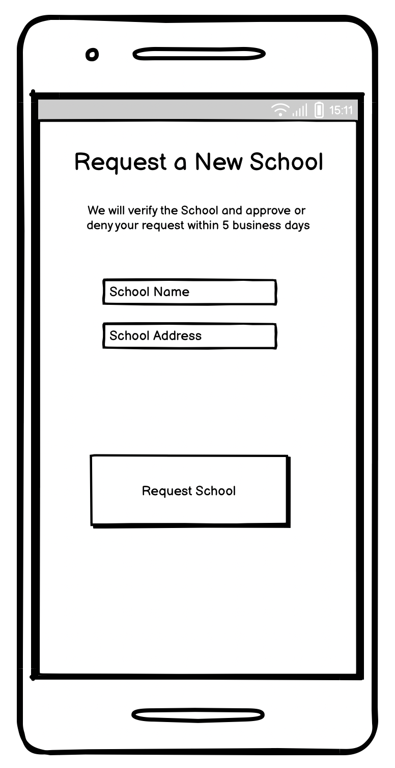

This page is where a user can request a new school. This happens when a student attends a school that is not already on the Scholar Saver’s list of approved institutions. The user will enter the name and address of the school they attend, and the request will be sent to the Scholar Saver review committee for approval.

This page is accessed in two distinct sequences of events. One is on account creation; the user can choose to request a new school if theirs is not already listed. The second is in the settings menu when the user is editing their profile.

**5.3.4 Home Page**

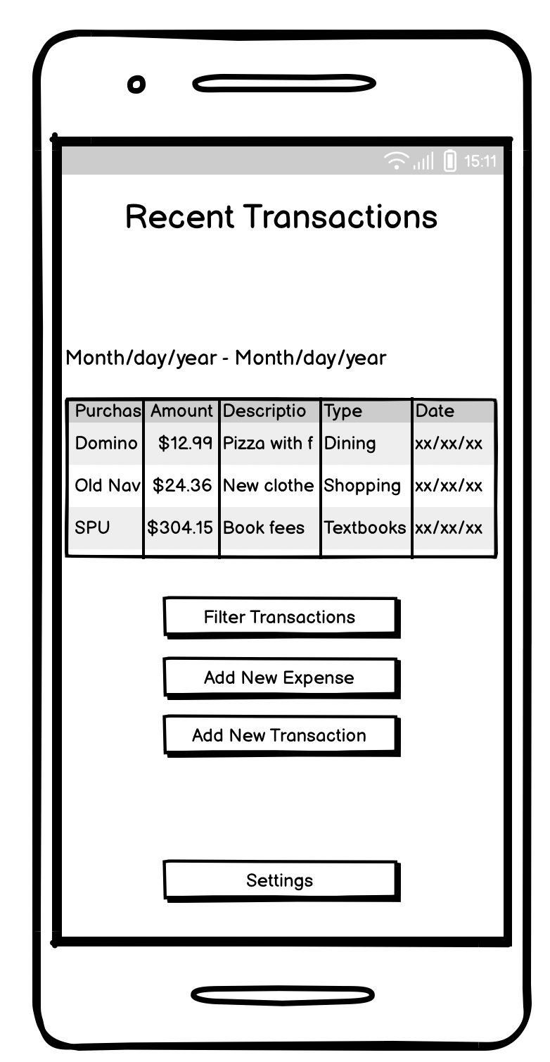

This is the main home page of Scholar Saver. This will be where the user primarily resides. The basic display of this page is the transaction list. In essence, it displays the transactions and their accompanying data to the user in a list. There is great flexibility in the design of the home page.

The transaction list defaults to the weekly view, where all transactions from the last week are shown. To see how the user can alter this view see § 5.3.6. However, these different viewing methods will reside on this same home page.

The user can select any individual transaction on this page for more details. This will open a separate page with more options (see § 5.3.8). It should be noted that this is how that page is opened.

**5.3.5 Filter Transactions**

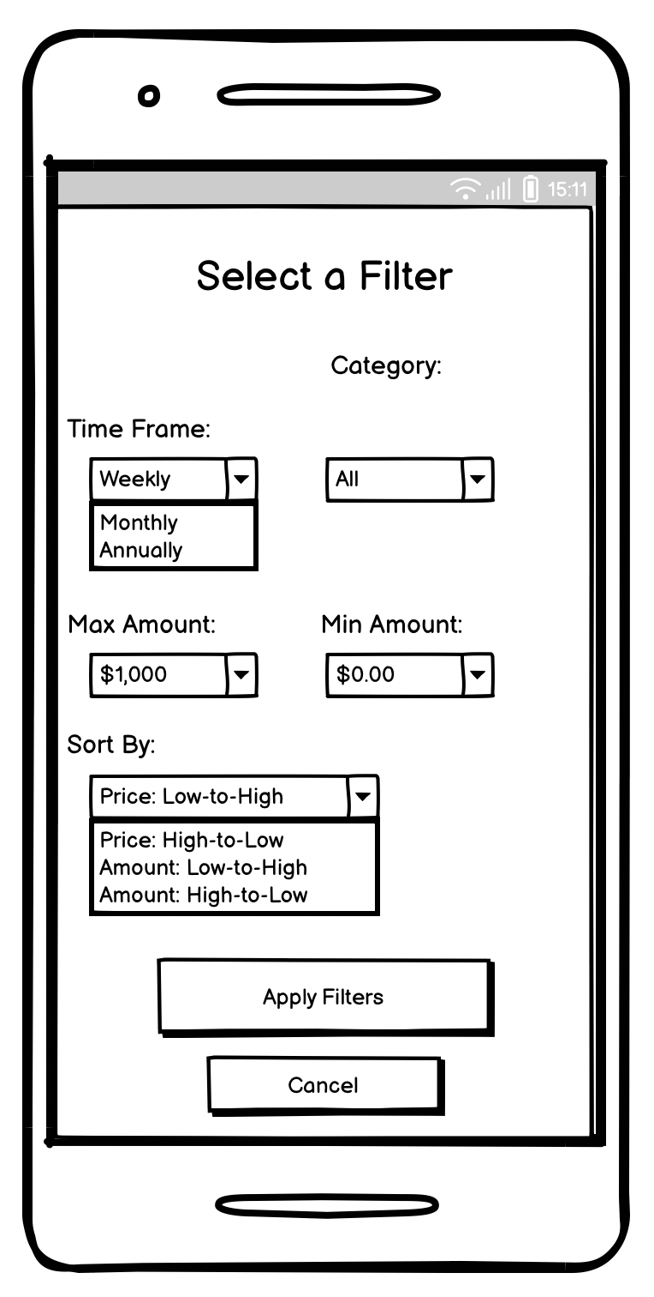

This page allows the user to filter the transaction list seen on the home page by several criteria. Note that the “Time Frame” filter is what changes the view on the home page to show weekly, monthly, or annual data.

**5.3.6 Add New Transaction**

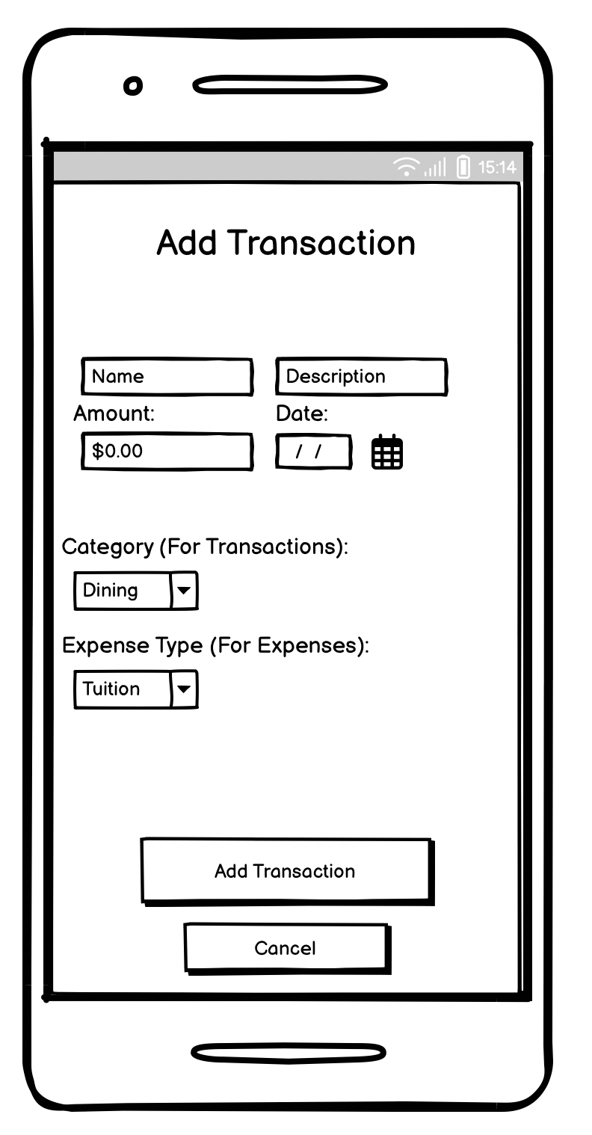

The user lands on this page when adding a new transaction or expense. While this page is labeled for adding transactions, it is used for both transactions and expenses. When adding a transaction, the last input element asks for the transaction category; these categories users may add to. However, the expense type input element is shown when adding an expense. These expense types are predetermined, and the user can not add to or remove from these types.

**5.3.7 Edit Transaction**

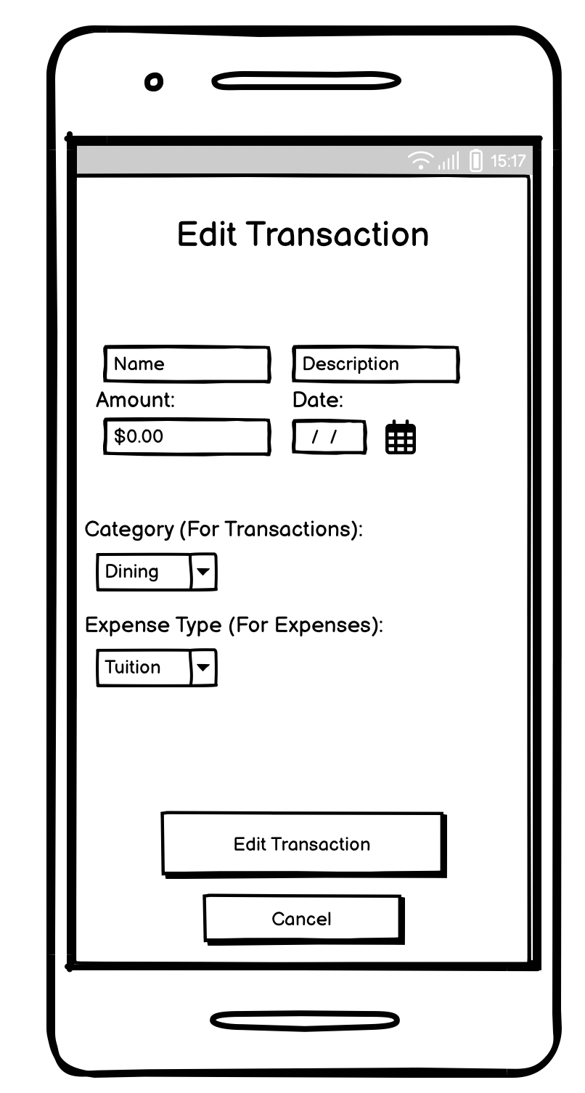

This page allows the user to edit transactions and expenses. Similar to adding transactions and expenses, this page will alter slightly depending on whether the user adds an expense or a transaction. The category and expense type input elements will be shown/hidden appropriately.

**5.3.8 View Transaction**

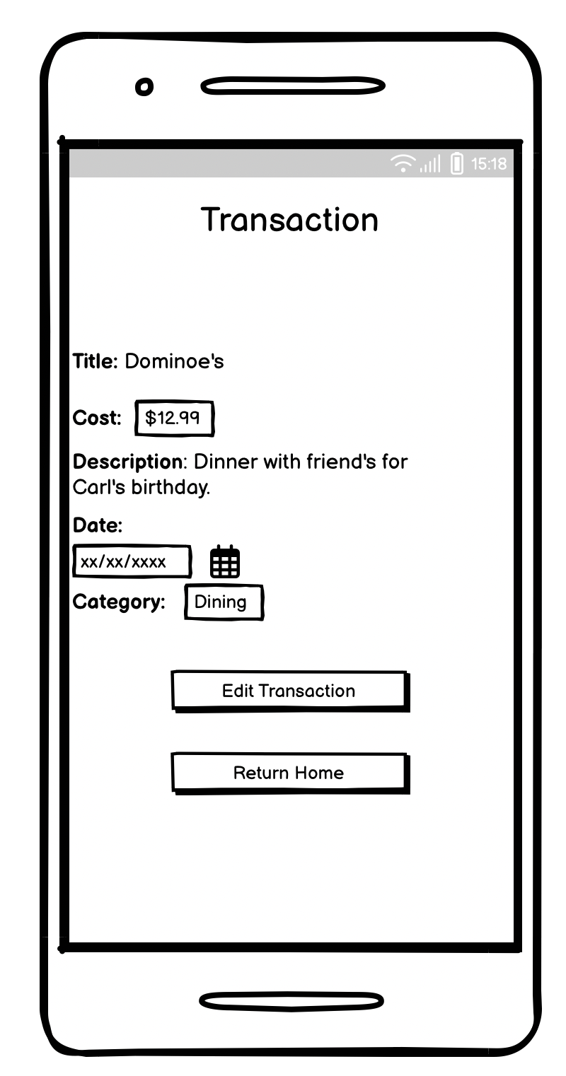

This page is shown when a transaction or expense is selected from the list on the home page. A transaction is displayed here, but the view will be almost identical for an expense. This display displays further information about a transaction or expense and allows users to edit it.

It should be noted that when the edit page is opened upon clicking the edit button on this page, the appropriate version of the edit page is shown, depending on whether the item is a transaction or an expense.

**5.3.9 Settings**

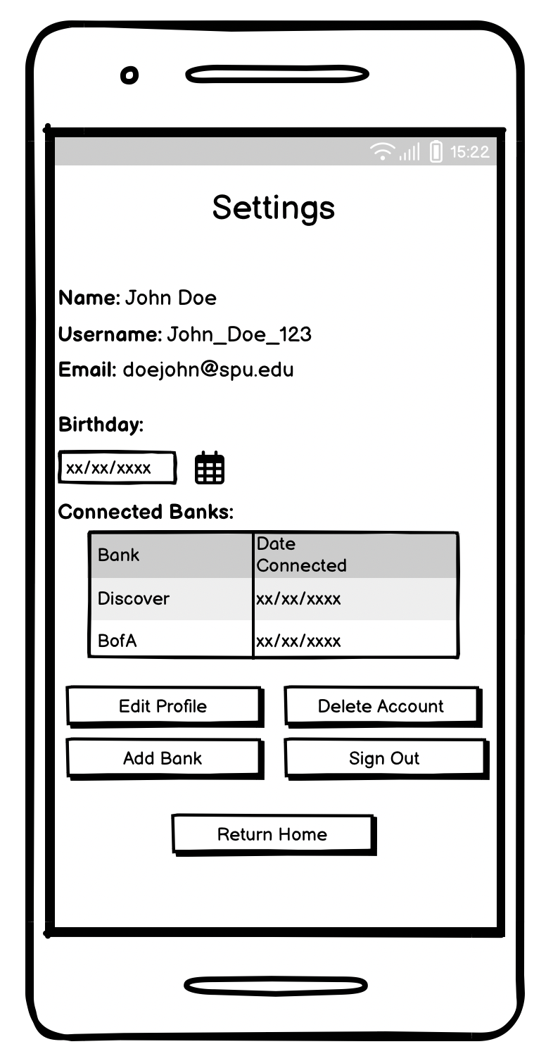

This is the user settings page. It shows information about the user’s account and allows for several functions. From here, the user can edit any part of their account. Additionally, the user can sign out and delete their account from here.

The user can also add online banking connections from this page. After clicking “Add Bank,” the user is redirected to the appropriate page.

**5.3.10 Edit Account**

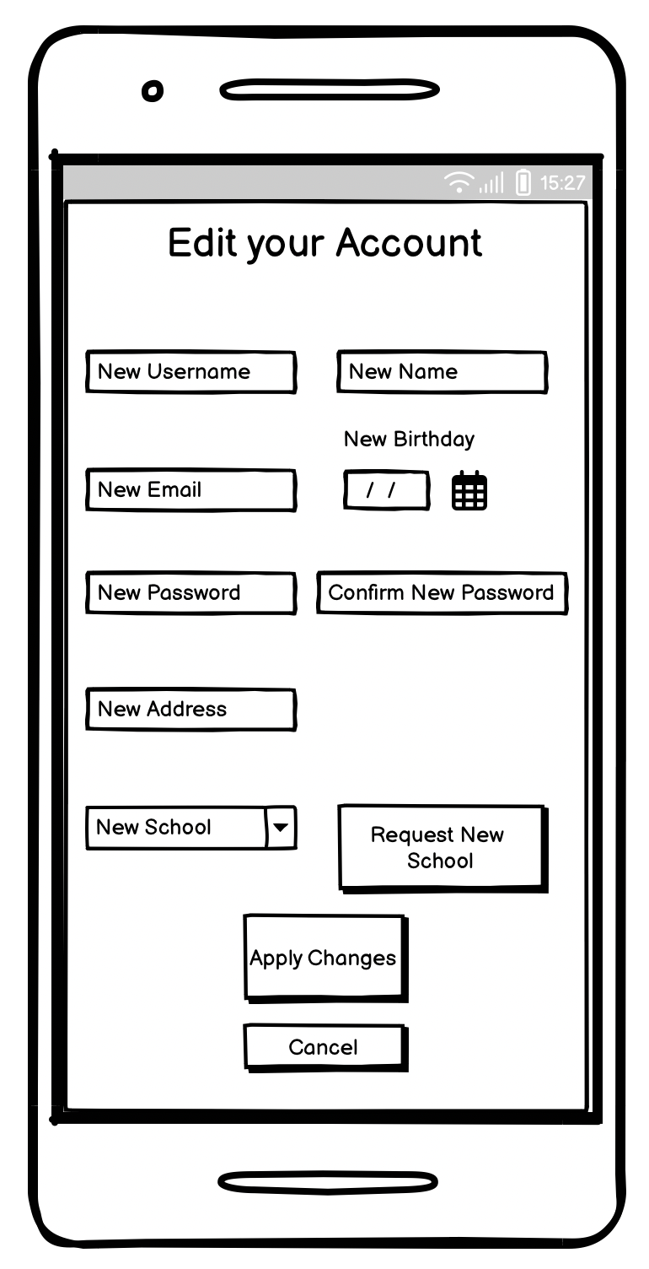

This page allows the user to edit their account. Similar to the account creation page, the user can input any new and updated information on this page. The updated information will update the user’s account appropriately. The request new school page can also be accessed from this page.

**5.3.11 Add Bank**

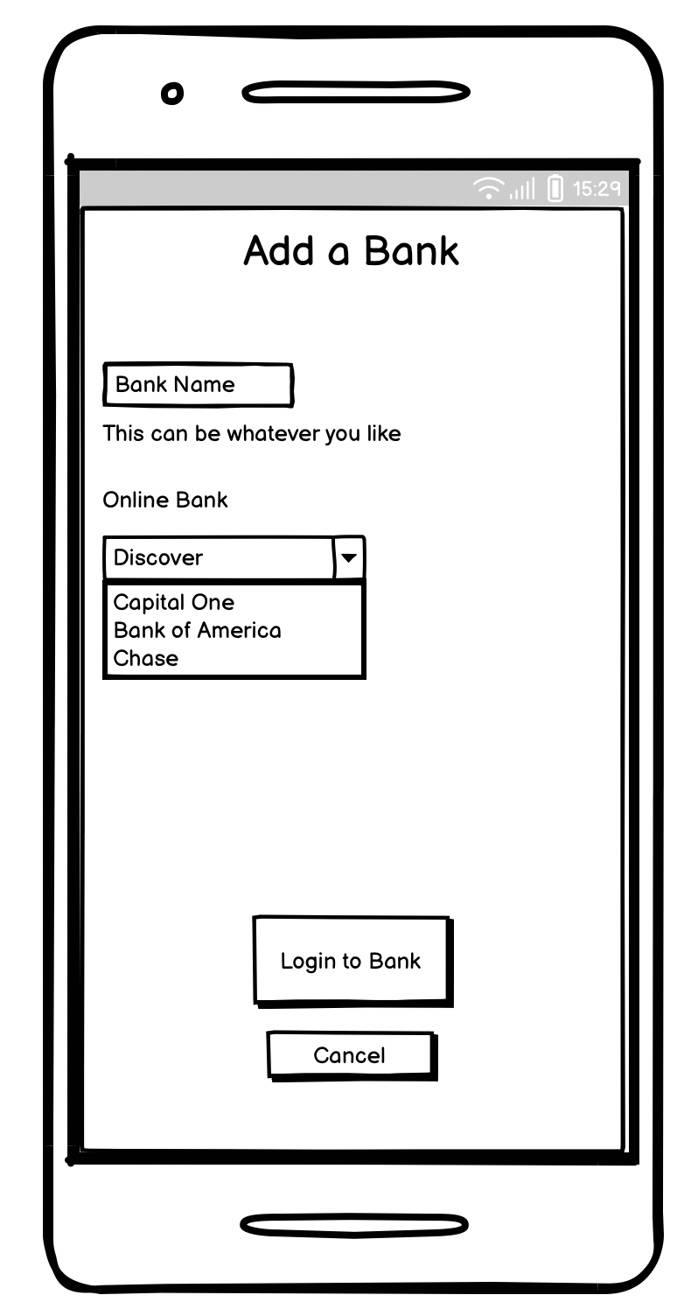

This is the page where the user can connect to new online banks. The user can choose any nickname for the bank and select the banking system. Because each bank offers information slightly differently, each bank will have to be manually accommodated by the developers. Because of this, only available banks can be connected. Users are taken to the respective login site when they select one of the available banks.

**5.3.2 External Bank Login**

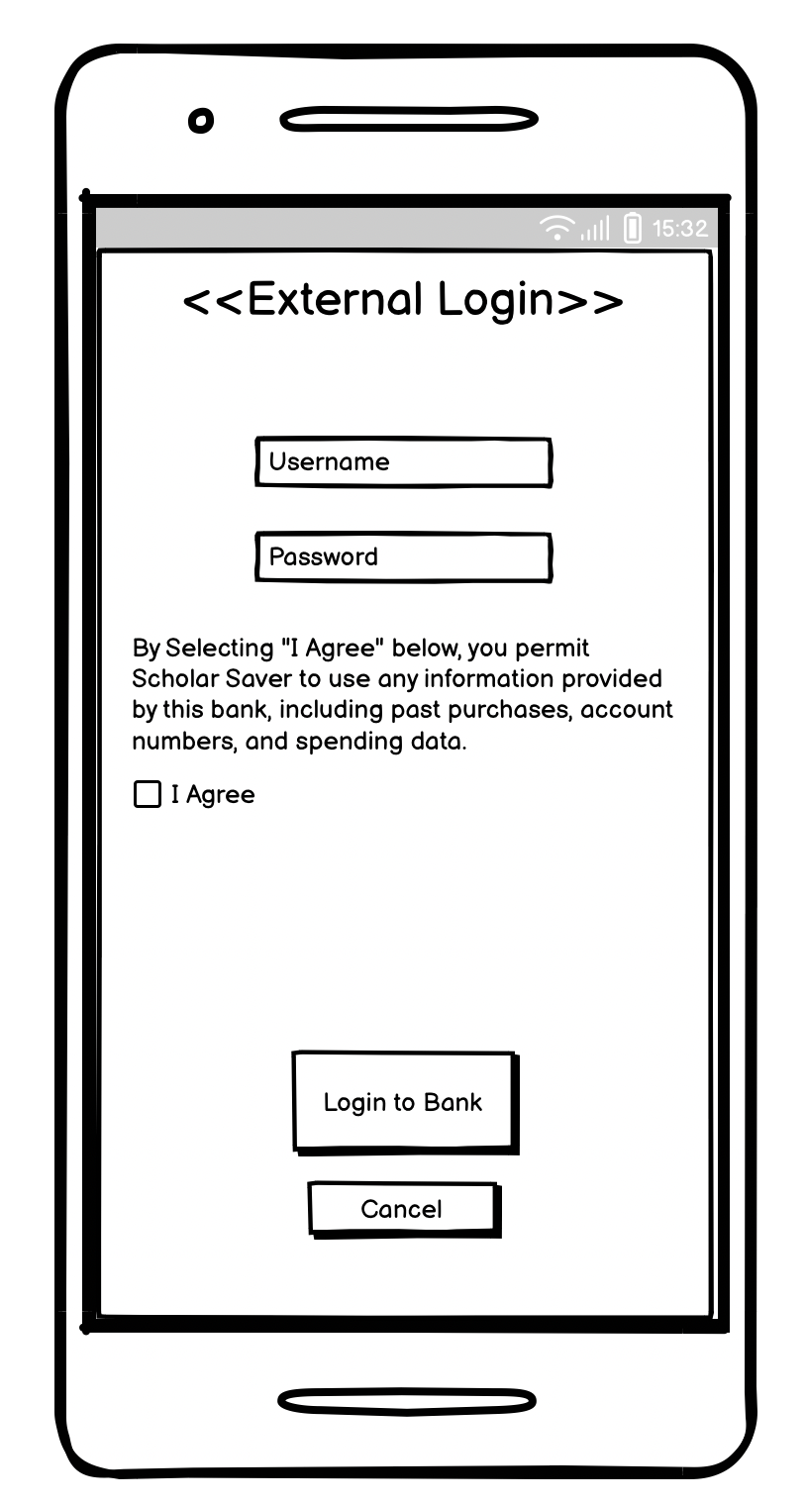

This is a generic template of an external login page when connecting to an online bank. This page is not part of Scholar Saver’s application, and the Scholar Saver developers will not create it. When the user logs in to their online bank system, the connection and authorization data are returned to Scholar Saver for processing.

## **Reports: "Formal Output" Design**

Scholar Saver does not plan any reports to be generated by the system at this time. In future versions, this may be implemented.

# **Appendices**

## **Glossary**

**RSS –** Resources for Striving Students; an educational company interested in providing the best resources to college students.

**BTC –** Big Tech Company, a large software company specializing in quickly developing software for clients.

**Scholar Saver –** A proposed mobile application to assist college students with personal finance.

**Student –** The primary users of Scholar Saver. Interchangeable with *user.*

**API –** Application Programming Interface.

**MVP** – Minimum Viable Product.

**TCP** – Transmission Control Protocol.

**IP** – Internet Protocol.

**ODBC** – Open Database Connectivity.

**SQL** – Structured Query Language.

**Microsoft Azure** – A Cloud computing platform owned and operated by Microsoft.

**UI** – User Interface.

**IDE** – Integrated Development Environment.

**HTTPS** – HyperText Transafer Protocol Secure.

**SSL** – Secure Sockets Layer.

**TLS** – Transport Layer Security.

## **References / Bibliography**

Cameron, Andy. (2024, May). *Physical Architecture Layer Dividing up the Work.*

*Intelligent diagramming*. Lucidchart. http://lucidchart.com/

Larman, C. (2004). *Applying UML and patterns: An introduction to object-oriented analysis and design and the unified process*. Pearson.

Nanavaty, N. (2023, October 25). *What is an open banking API? How apps and accounts connect*. Plaid. <https://plaid.com/resources/open-finance/open-banking-api/>

Ideal Modeling & Diagramming Tool for Agile Team Collaboration. <https://www.visual-paradigm.com/>

Balsamiq Wireframes - Industry Standard Low-Fidelity Wireframing Software. <https://balsamiq.com/wireframes/>

## **Supporting documentation**

No further supporting documents are necessary.